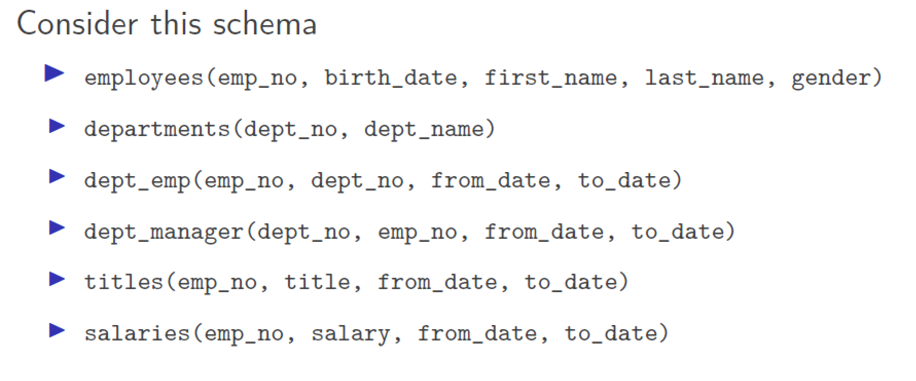

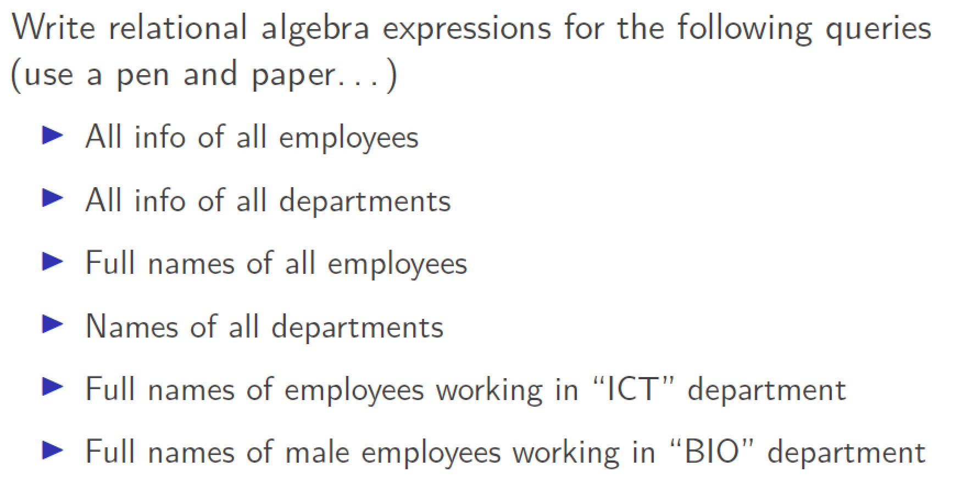

1) All info of all employees:

Πemp_no, bod, Fname, Lname, gender **(**employees)

2) All info of all department

Π dept_no, dept_name (departments)

3) Full name of all employees

Π first_name, last_name (employees)

🡪 Π first_name (employees) U Π last name (employees)

4) Name of all department

Π (dept_name (departments))

5) Full names of employees working in “ICT” department

Π first_name, last_name (σ dept_name=“ICT”(employees **⋈** departments))

**6) Full names of male** employees working in “BIO” **department**

Π first_name, last_name (σ gender = “male” ^ dept_name = “BIO“ (employees **⋈** departments**)**)

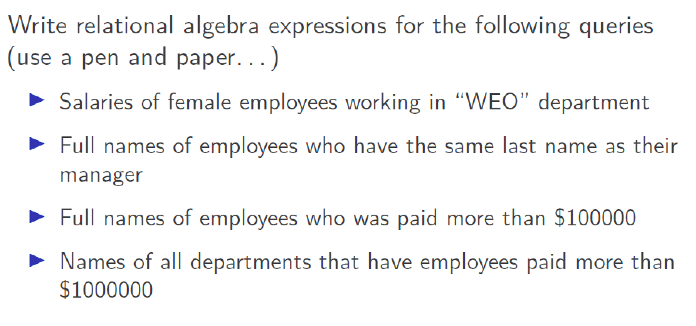

7) Salary of female employees working in “WEO” department

**Π salary** ( σ gender=“female” ^ dept_name=“WEO” (employees **⋈** departments **⋈ salaries))**

**8) Full names of** employees who has the same last names as their manager

Π first_name, last_name ( σ (employees **⋈** depd**))**

**dept_no.**

9) Full name Employee who was paid more than 100.000$

Π first_name, last_name ( σ **salary > 100k$ (**employees **⋈ salaries))**